Client:-

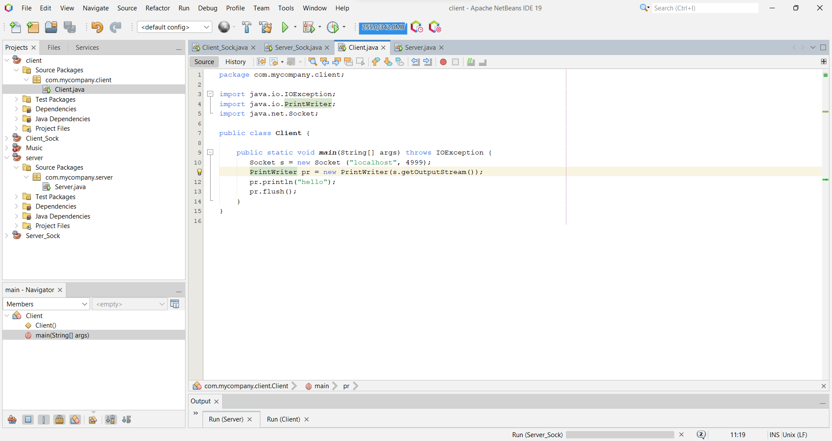

Server:-

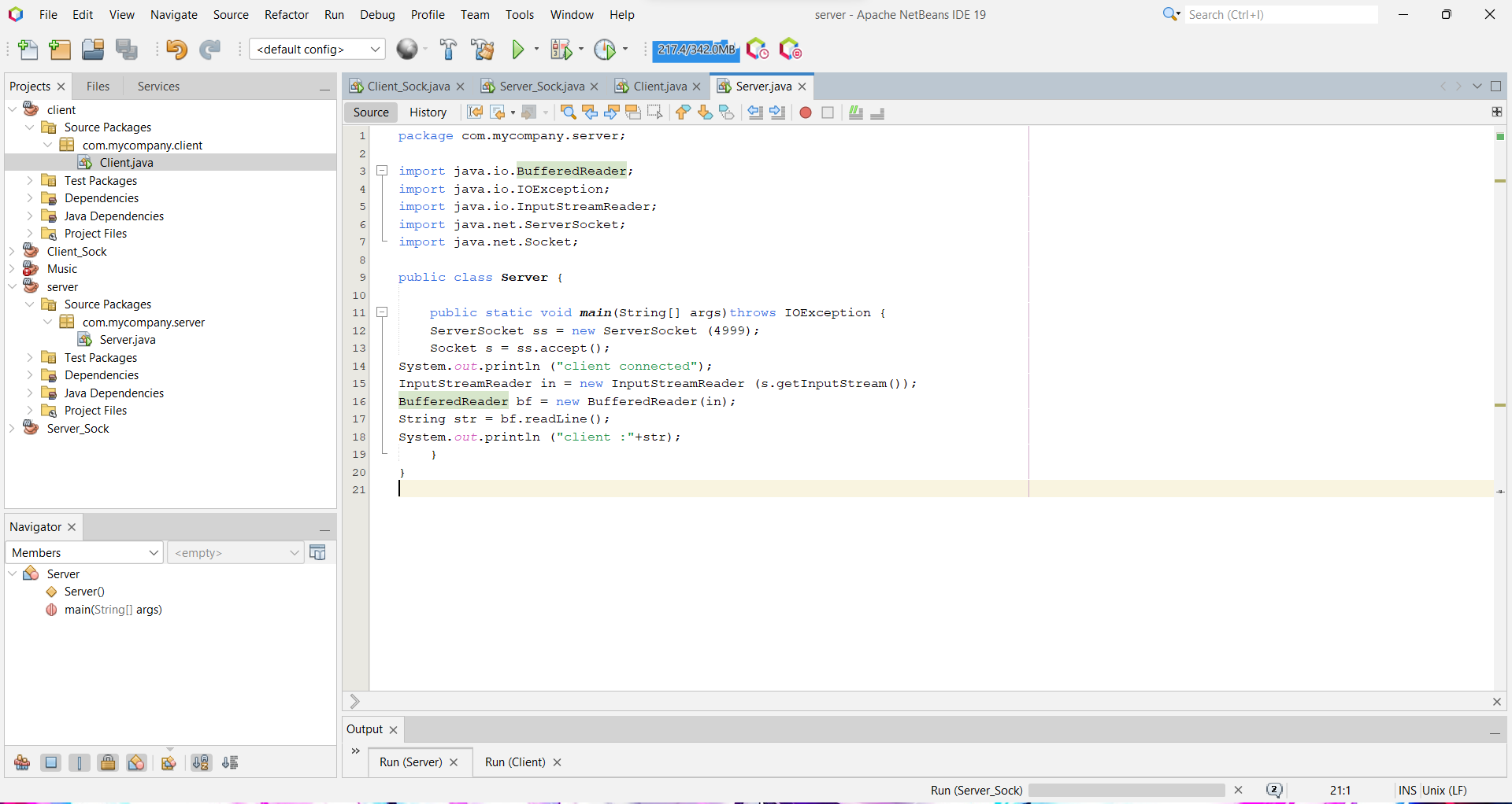

Client side code :- File Name :- Client

package com.mycompany.client;

import java.io.IOException;

import java.io.PrintWriter;

import java.net.Socket;

public class Client {

public static void main(String[] args) throws IOException {

Socket s = new Socket ("localhost", 4999);

PrintWriter pr = new PrintWriter(s.getOutputStream());

pr.println("hello");

pr.flush();

}

}

Output:-

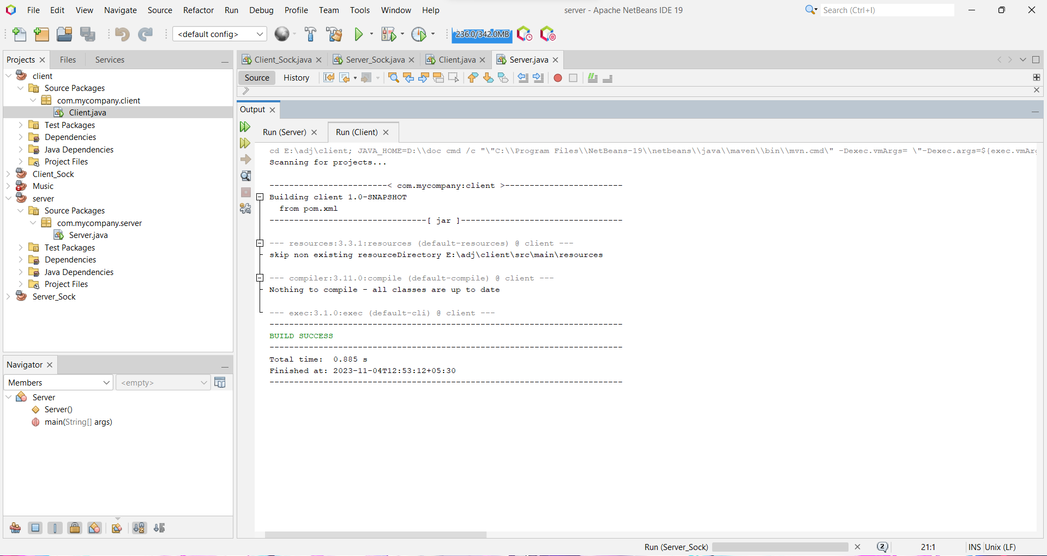

Server side code :- File Name :- Server

package com.mycompany.server;

import java.io.BufferedReader;

import java.io.IOException;

import java.io.InputStreamReader;

import java.net.ServerSocket;

import java.net.Socket;

public class Server {

public static void main(String[] args)throws IOException {

ServerSocket ss = new ServerSocket (4999);

Socket s = ss.accept();

System.out.println ("client connected");

InputStreamReader in = new InputStreamReader (s.getInputStream());

BufferedReader bf = new BufferedReader(in);

String str = bf.readLine();

System.out.println ("client :"+str);

}

}

Output:-

